（R语言）线性混合效应模型

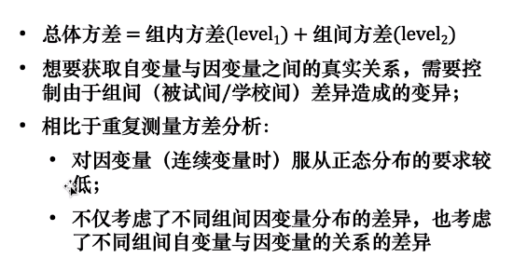

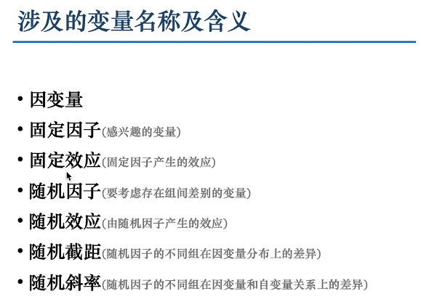

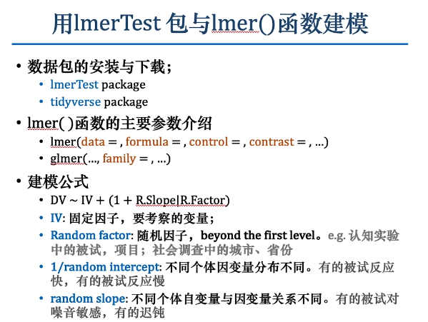

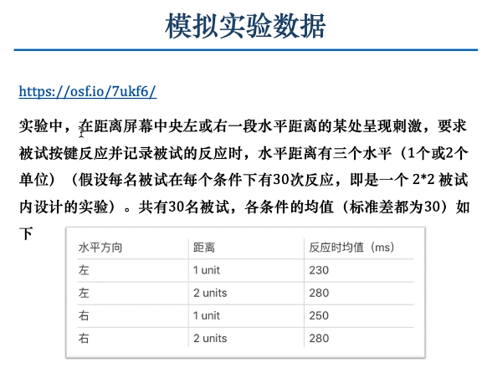

library(lmerTest)

library(tidyverse)

source('D:/Users/huxiaoyi/Desktop/mixedDesign.v0.6.3.R')

DF=tibble()

DF

for(ii in 1:30){

df=mixedDesign(W=4,n=30,SD=30,

M=matrix(c(230,280,250,280), nrow =1),long = T)

df['direction']=ifelse(df$W_a %in% c('a1','a2'),'left','right')

df['distance']=ifelse(df$W_a %in% c('a1','a3'),'unit1','unit2')

DF=rbind(DF,df)

}

item=c()

for (ii in 1:120){

item=c(item,sample(1:30,size = 30,replace = F))

}

DF=DF %>% arrange(W_a,id) %>%

mutate(item=item)

DF=DF[c('id','item','direction','distance','DV')]

DF[c('id','item','direction','distance')]=lapply(DF[c('id','item','direction','distance')],factor)

str(DF)

DF$DV <- as.numeric(DF$DV)

###全模型与零模型###

Modelmax <- lmer(data = DF,

formula = DV~direction*distance+(1+direction*distance|id)+(1+direction*distance|item),

control = lmerControl(optimizer='bobyqa'))

Modelzero <- lmer(data = DF,

formula = DV~direction*distance+(1|id)+(1|item),

control = lmerControl(optimizer='bobyqa'))

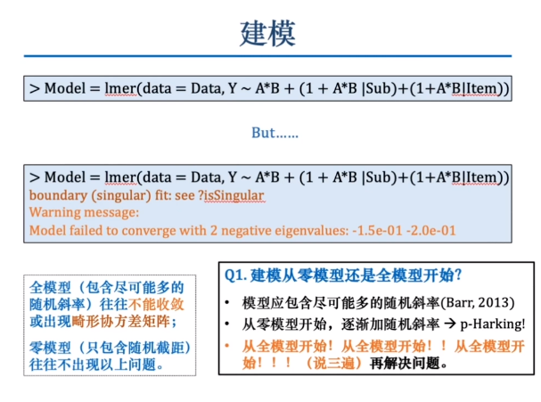

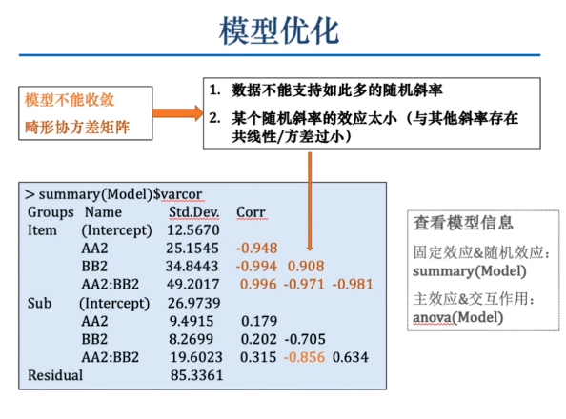

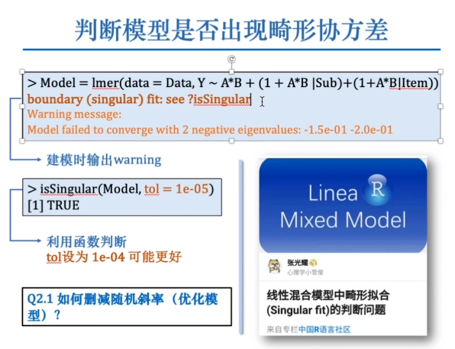

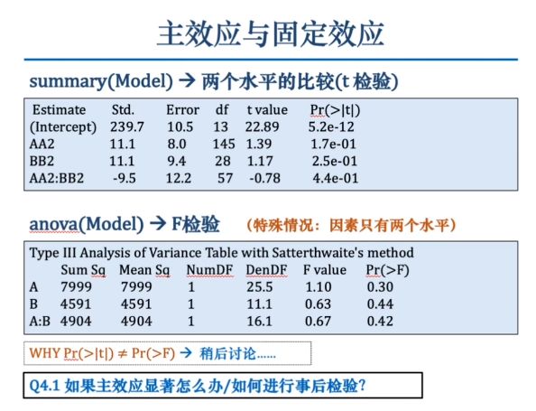

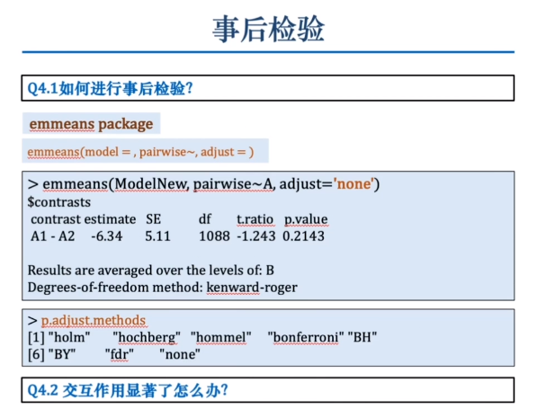

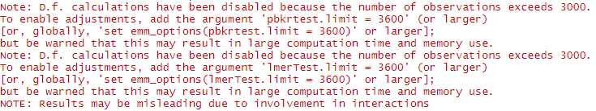

emm_options(pbkrtest.limit = 3600)

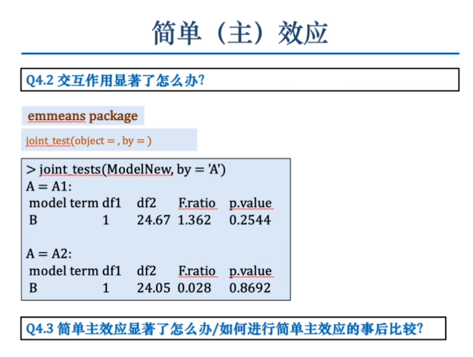

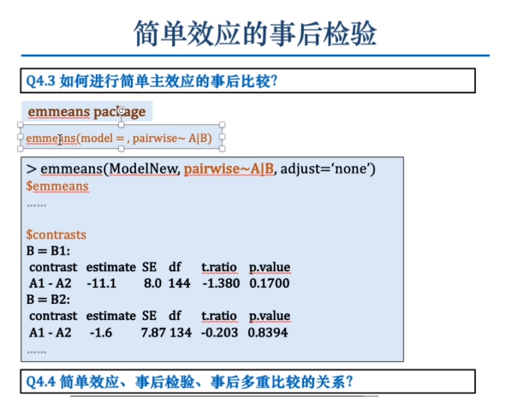

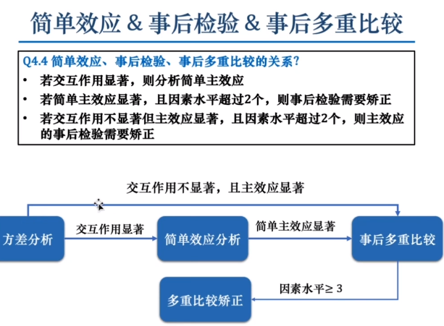



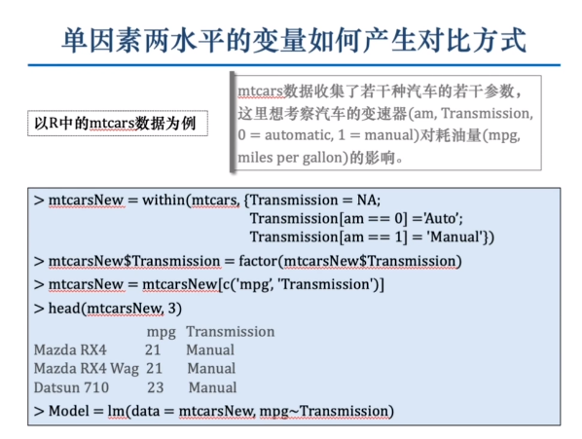

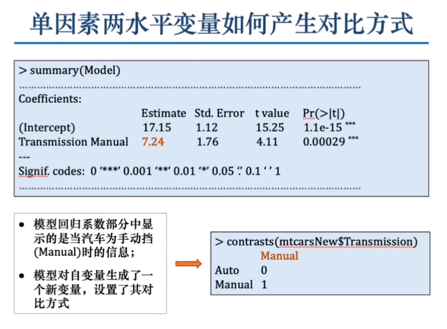

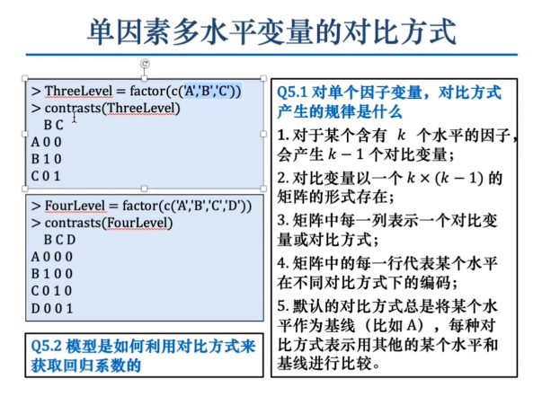

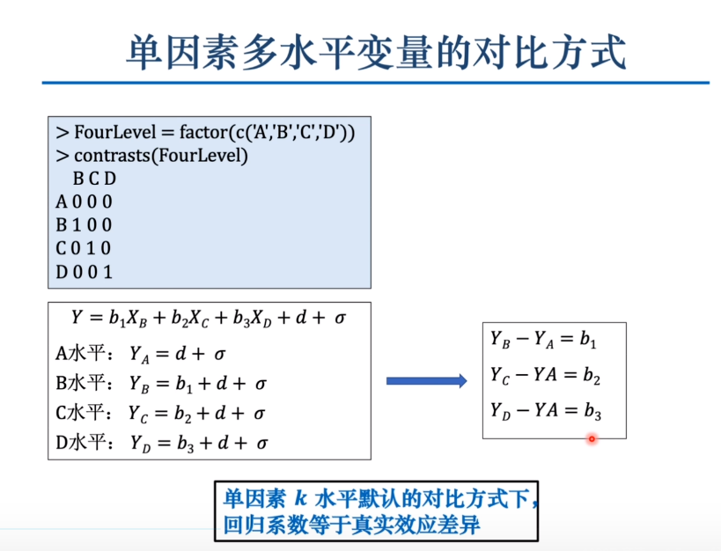

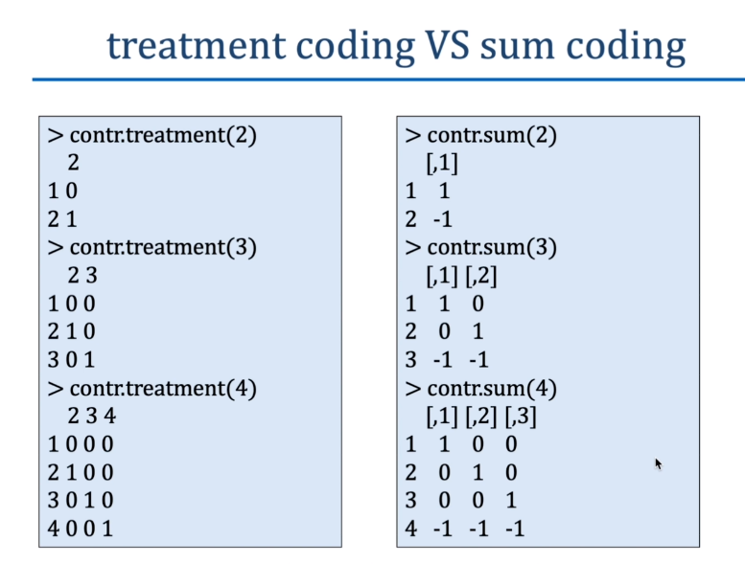

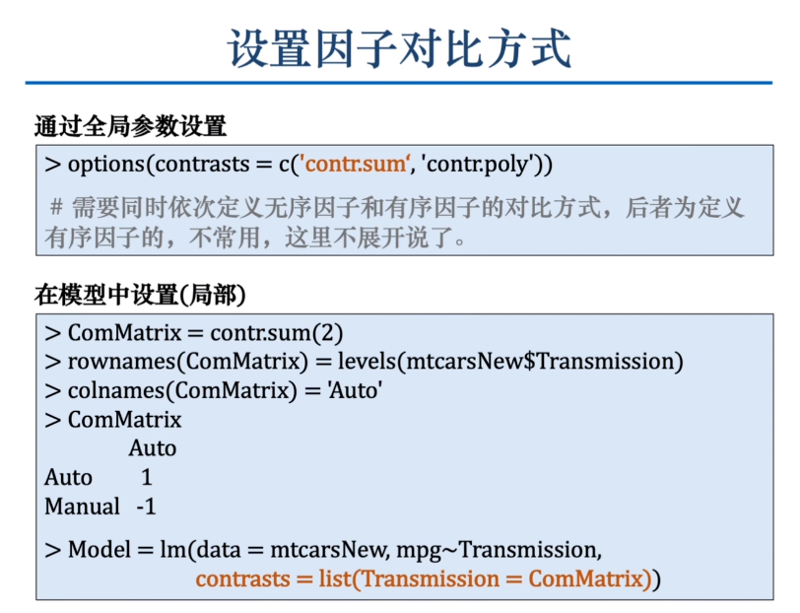

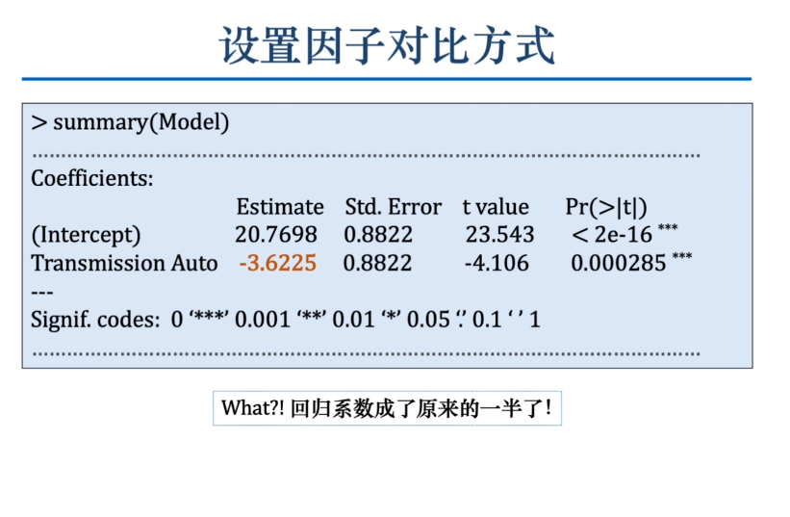

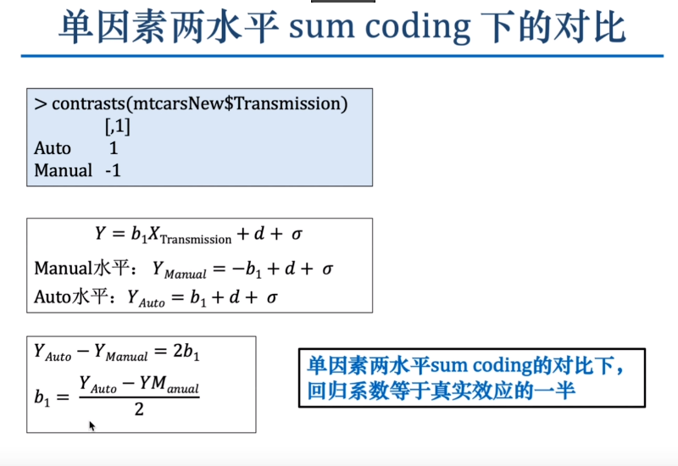

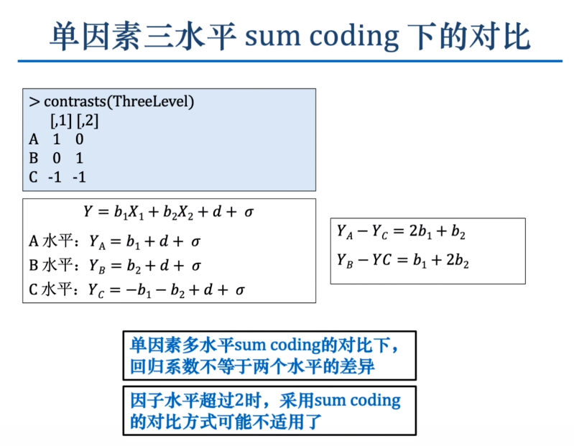

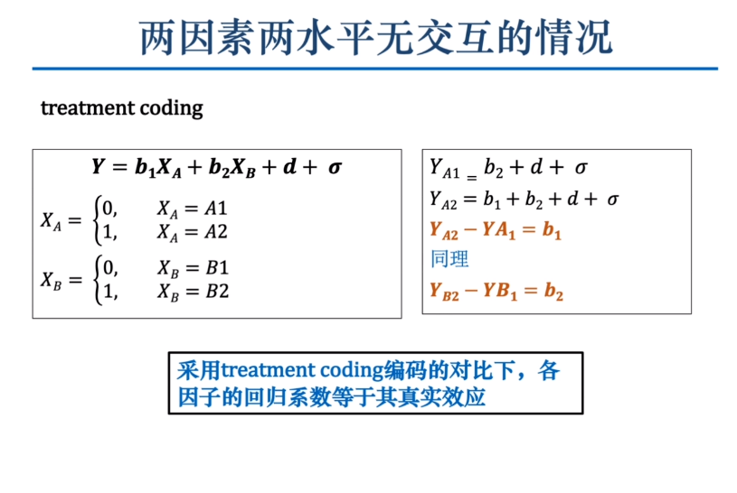

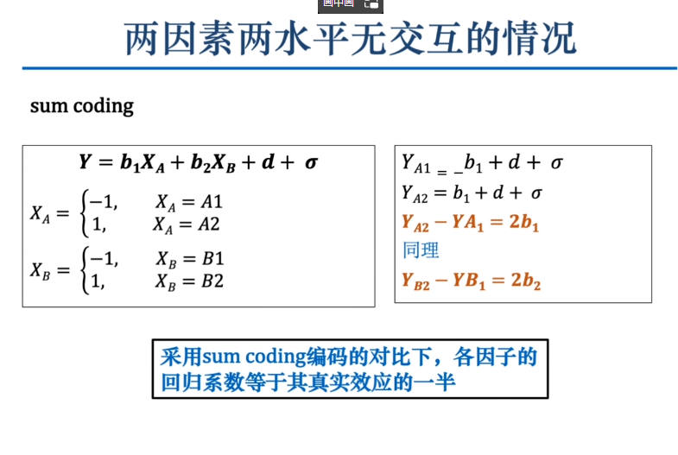

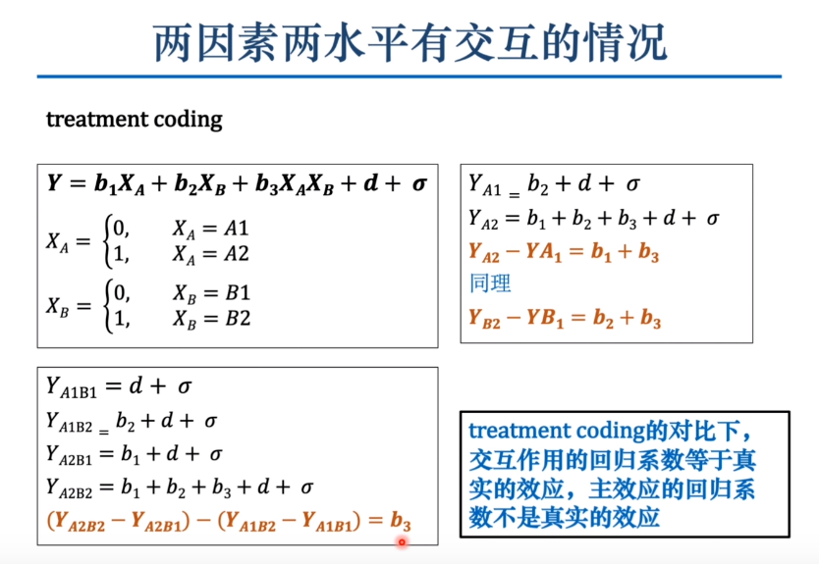

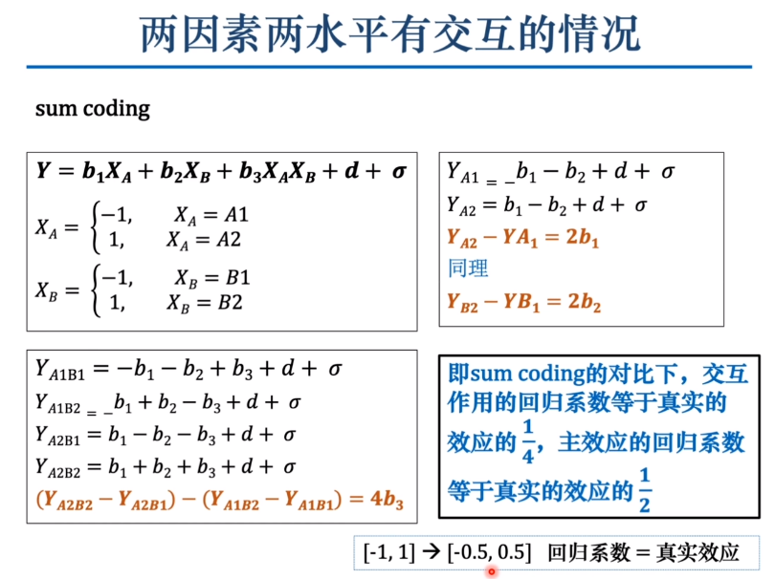

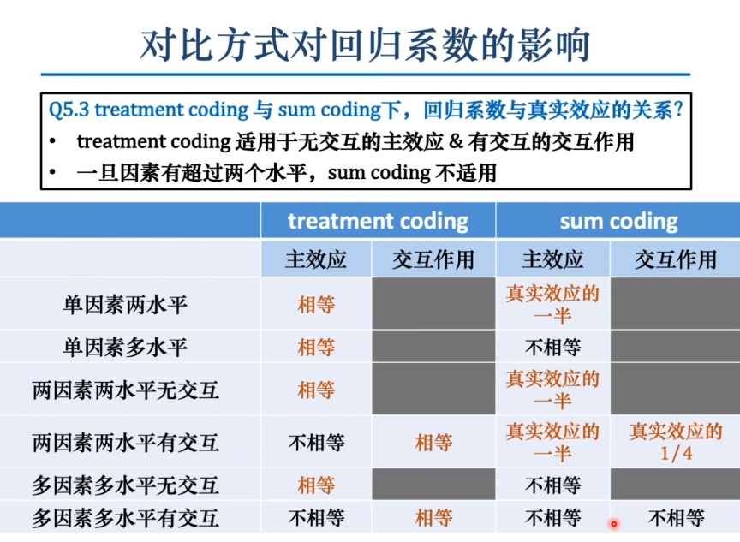

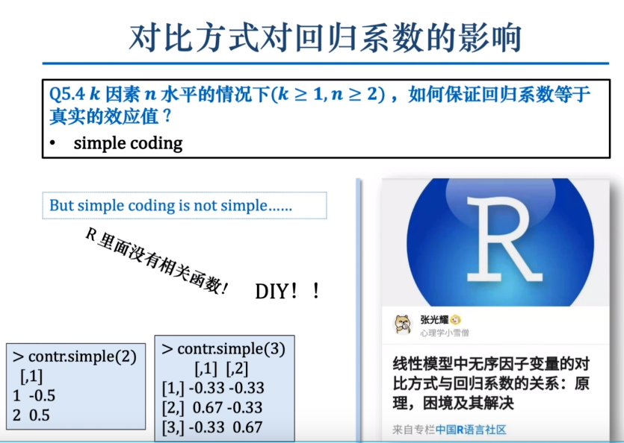

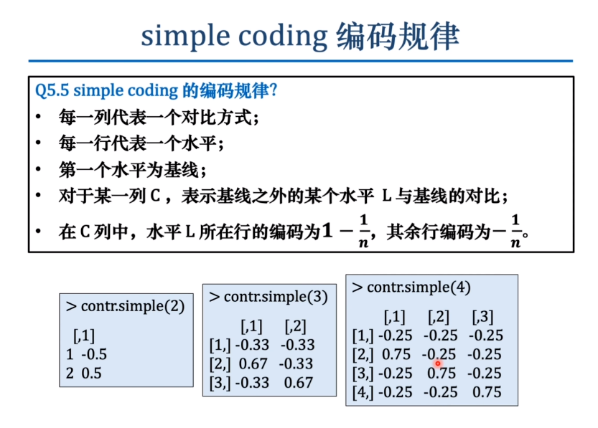

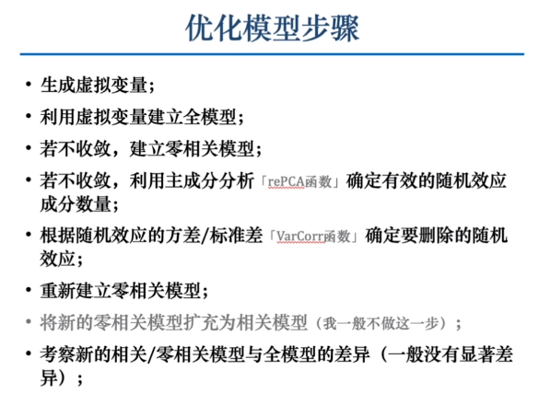

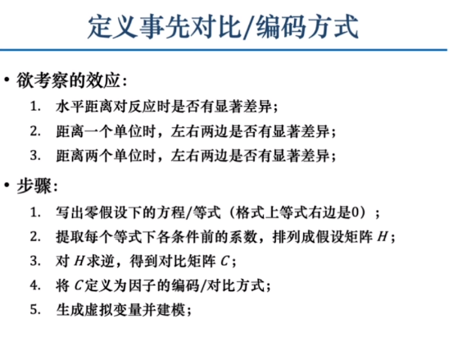

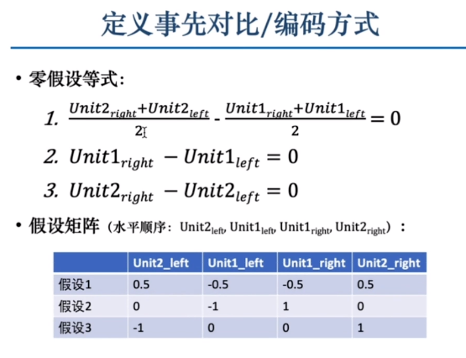

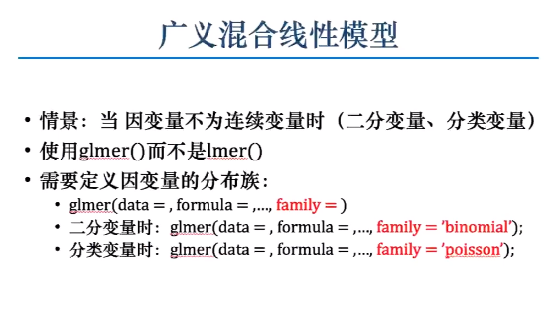

summary(Modelzero)

anova(Modelzero)

library(emmeans)

emmeans::emmeans(Modelzero,pairwise~direction)

emm_options(pbkrtest.limit = 3000)

emmeans::emmeans(Modelzero,pairwise~direction)

emmeans::joint_tests(Modelzero,by='direction')

emmeans::emmeans(Modelzero,pairwise~distance|direction)

contrasts(DF$direction)

contrasts(DF$distance)

M=model.matrix(~direction*distance,DF)

M

DF[c('right','unit2','right_unit2')]=M[,c(2:4)]

View(DF)

contrasts(DF$direction)=contr.sum(2)

contrasts(DF$distance)=contr.sum(2)

contrasts(DF$direction)

contrasts(DF$distance)

M=model.matrix(~direction*distance,DF)

view(M)

DF[c('right','unit2','right_unit2')]=M[,c(2:4)]

###用主成分分析优化模型###

contrasts(DF$direction)=c(-0.5,0.5) #定义direction的对比方式

contrasts(DF$distance)=c(-0.5,0.5) #定义distance的对比方式

M=model.matrix(~direction*distance,DF) #手动生成虚拟变量

DF[c('right_left','unit2_1','interaction')]=M[,c(2:4)]

View(DF)

Modelmax <- lmer(data = DF,

formula = DV~direction*distance+(1+right_left+unit2_1+interaction|id)+(1+right_left+unit2_1+interaction|item),

control = lmerControl(optimizer='bobyqa'))

Modelzero <- lmer(data = DF,

formula = DV~direction*distance+(1+right_left+unit2_1+interaction||id)+(1+right_left+unit2_1+interaction||item),

control = lmerControl(optimizer='bobyqa'))

summary(rePCA(Modelzero))

VarCorr(Modelzero)

Modelopt<- lmer(data = DF,

formula = DV~direction*distance+(1+right_left+unit2_1||id)+(-1+unit2_1||item),

control = lmerControl(optimizer='bobyqa'))

anova(Modelmax,Modelopt)

###定义事先对比###

DF=DF[,1:5]

DF['condition']=paste0(DF$distance,"_",DF$direction)

view(DF)

DF$condition=factor(DF$condition,

levels = c('unit2_left','unit1_left','unit1_right','unit2_right'))

levels(DF$condition)

H=rbind(c(0.5,-0.5,-0.5,0.5),

c(0,-1,1,0),

c(-1,0,0,1))

rownames(H)=paste0('H',1:3)

colnames(H)=levels(DF$condition)

MASS::ginv(H)

C=MASS::ginv(H)

rownames(C)=colnames(H)

colnames(C)=rownames(H)

contrasts(DF$condition)=C

M=model.matrix(~condition,DF)

DF[paste0('H',1:3)]=M[,2:4]

Modelmax <- lmer(data = DF,

formula = DV~H1+H2+H3+(1+H1+H2+H3|id)+(1+H1+H2+H3|item),

control = lmerControl(optimizer='bobyqa'))

Modelzcp<- lmer(data = DF,

formula = DV~H1+H2+H3+(1+H1+H2+H3||id)+(1+H1+H2+H3||item),

control = lmerControl(optimizer='bobyqa'))

summary(rePCA(Modelzcp))

VarCorr(Modelzcp)

Modelopt<- lmer(data = DF,

formula = DV~H1+H2+H3+(1+H1+H2+H3||id)+(-1+H1||item),

control = lmerControl(optimizer='bobyqa'))

anova(Modelmax,Modelopt)

H

t(H)

cor(t(H))

summary(Modelopt)

if(!require(devtools)) install.packages("devtools")

devtools::install_github("usplos/YawMMF")

library(YawMMF)

head(DemoData2)

DemoData2$CondA=factor(DemoData2$CondA,levels = c('A1','A2'))

DemoData2$CondB=factor(DemoData2$CondB,levels = c('B1','B2'))

contrasts(DemoData2$CondA)=c(-0.5,0.5)

contrasts(DemoData2$CondB)=c(-0.5,0.5)

Model=glmer(data = DemoData2,DV~CondA*CondB+(1|item),

family = "binomial")

summary(Model)

##anova(Model)

car::Anova(Model,type=3)

summary(Model)$coef %>% round(3)

emmeans(Model,pairwise~CondA|CondB)

DemoData2 %>% group_by(subj,CondA,CondB)%>%

summarise(Reg=mean(DV))%>%

group_by(CondA,CondB)%>%

summarise(MeanReg=mean(Reg))